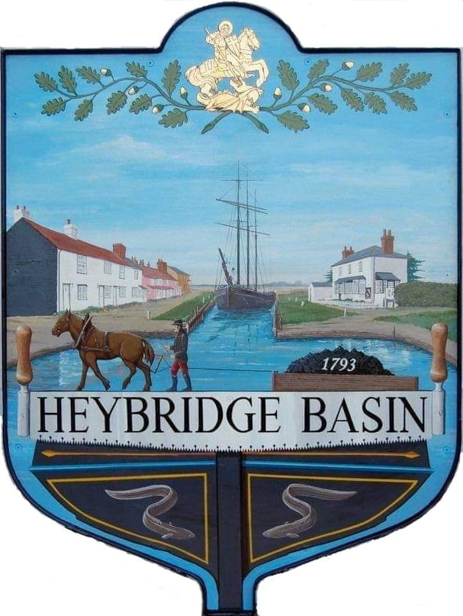

HEYBRIDGE BASIN PARISH COUNCIL

Minutes of the Extraordinary meeting of Heybridge Basin Parish Council held on Friday 1st December 2023 at 6.00pm, at The Lock Tea Room.

PRESENT

In the Chair: M. Hodges Apologies: 0

Councillors: M. Hobden C. Edmond Absent: 0
R. Bryson J. Sjollema
G. Howat C. Swann Public: 0

Officers: G. Lake – Clerk

It was noted that this meeting was being recorded by the Clerk.

23/124 Chair’s Welcome
Cllr Hodges opened and welcomed everyone to the meeting.

23/125 Apologies for Absence.
There were no apologies.

23/126 To receive Declarations of Interest in accordance with the Council’s Code of Conduct and with section 106 of the Local Government Finance Act 1992.
Cllr Hobden – Non-Pecuniary – HBSA, Basin Oars and HB Rivercare; Cllr Howat – Non-Pecuniary – HBCSA

Cllr Swann arrived at 18:04pm
The meeting was paused to resolve an issue with parking.
The meeting resumed at 18:06pm

Declarations of interest from Cllr Swann were received – Non-Pecuniary – DMCP and owner of the Tearoom.

23/127 Daisy Meadow Car Park
  - To consider the Civil Designer quotations and agree any action to be taken.
Three quotes were received. It was resolved to accept the quote from Haydn Evans including the three surveys.
It was noted that the quote from Haydn Evans was the most competitive.
  - To receive an update from the Clerk and agree any action to be taken.
An update was received regarding works which had commenced within the car park. It was resolved to accept the variation of contract quote of £1,192.00 from HRS Marine Services to create a raised planting area with railway sleepers. Cllr Swann abstained from the vote.

23/128 New Government Guidance on Biodiversity
- To consider the new government guidance on biodiversity and agree any action to be taken.
Cllr Hodges previously circulated the NALC model Biodiversity policy to all members. It was resolved that all members would review the model policy and email the Clerk with any suggestions and amendments.

23/129 Clerks Christmas Hours
  - To consider the Clerk’s working hours over the Christmas period and agree any action to be taken.
It was resolved that the Parish Council would be closed from Wednesday 20th December and re-open on Thursday 4th January.

23/130 Budget 2024/2025
- To consider the budget for 2024/2025 and agree any action to be taken.
The budget for 2024/2025 was considered. Cllr Edmond advised Council that the Kiosk by the canal were happy to mount a defibrillator on the Kiosk as well as provide the electricity providing it was marked as being the Parish Council’s responsibility. It was resolved to add the costings of a defibrillator into the budget spreadsheet and discuss further at the next meeting.

There being no further business the meeting closed at 06:52pm
Provisional Date of the next Council Meeting Tuesday 12th December 2023.

Clerk Contact details: clerk@heybridgebasinpc.org.uk
Website: www.heybridgebasin-pc.gov.uk

